I decided to fulfill my own request for this month. Also I didn’t have much time to spend writing a new app, so I decided to grab Lifecycle Event Editor code from the EXE and tweak it to run inside Vault Explorer.
The plug-in itself has the exact same feature set as the exe. But if you are not familiar with it, here is a quick run down. You can use the Lifecycle Event Editor to tell the server to fire jobs when objects move through specific lifecycle states. For example, you want a job of type “Dougpunch” to be created every time a file goes from In Review to Released, you might set something up like this.
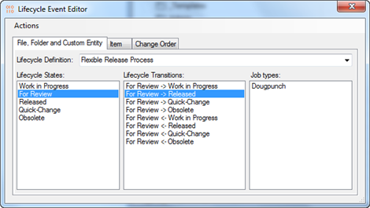
If you commit the changes then look at the Job Queue... you won’t see anything. The Lifecycle Event Editor does actually put any jobs on the queue, it just lets you configure the server settings. The “Dougpunch” jobs show up when you move files from In Review to Released.
Of course, if you try this out in your Vault nothing interesting will happen. It will just result in a bunch of Dougpunch jobs on the queue that sit there until deleted. There is nothing configured to handle Dougpunch jobs. At least I hope there is not.
The lifecycle event feature is useful for when you define your own job types through the API. There are also some utilities, such as Project Sync, which hook into this framework.

Requirements:
- Vault 2013 Workgroup / Collaboration / Professional
- Job Queue enabled
- Admin rights
Click here to download the application
Click here to download the source code
As with all the samples on this site, the legal disclaimer applies.

